Interview Essentials

If you get the interview that is your one chance of getting the job you want! Don't miss out on an opportunity because you do not know the basic guidelines that govern any interview process. Be Prepared!
Before the Interview:
• Research the company. It’s also good to research the industry and the competition.
• Prepare your 30-second personal pitch.
• List questions to ask the interviewer.
• Get permission from your references to use their names, & have a reference list ready (3 contacts).
• Prepare your interview answers. Do a Mock-Interview.
• List the qualities you possess that fit the job requirements—have examples of each.

Common Interview Questions:
• Tell me about yourself?
• Why should we hire you?
• What do you know about this company?
• What are your goals?
• What are your strengths and weaknesses?
• Why do you want to work here?
• What has been your most significant achievement?
• How would your last boss describe you?
• What are your salary expectations?

The Interview:
• Dress for Success. Look your best.

Items to Bring to the Interview:
• Several copies of your resume on quality paper
• A copy of your references (3 is the magic number)
• A pad/pen to take notes, in a folder
• A portfolio of your work you want to showcase
• Clear directions on how to get to the interview
• The interviewer's contact information (phone/room number)

Upon Arrival:
• Arrive early. 15 minutes before your appointment.
• Announce yourself to the receptionist in a professional manner.
• Engage the people around you while you wait.
• Go to the restroom and check your appearance one last time.
• Stand and greet your interviewer with a firm handshake.
• Smile and maintain eye contact.

During the Interview:
• Try to focus on the points you have prepared without sounding stiff.
• Learn what you can about the company. Seem interested!
• Ask questions and listen, always trying to engage the interviewer.
• At the conclusion, thank the interviewer and inquire about the next step.
• At the end, ask for a business card so you can send a follow-up letter.

After the Interview:
• Send a thank-you letter within 24 hours, restating your fit for the job.
• Follow up after 2 weeks stating your interest, and to see if they made a decision.
• If you did not get the job, ask for feedback.
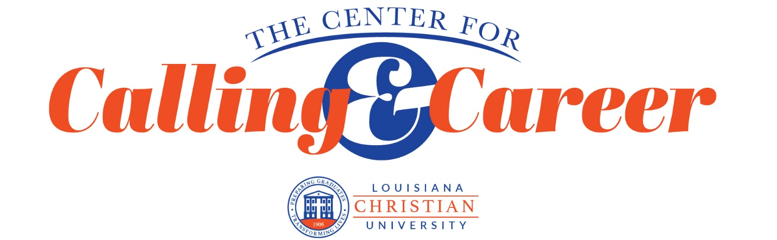
• If they have not made a decision, restate why you are the best candidate.

